USERS’ MANUAL

This user manual is a comprehensive guide to setting up and utilizing HydroSense. It enables real-time monitoring of water quality by interfacing with various sensors included in the package. This manual provides step-by-step instructions for connecting the TDS, pH, turbidity, and temperature sensors, as well as powering the device using a power bank or USB charger. It also learns how to access the web application hosted by the device and navigate through the Home, Live Data, Historical Data, Hydrology Resources, and About interfaces. Detailed diagrams and examples are included to simplify the setup and operation process. By following this guide, it effectively uses HydroSense to make informed decisions about water safety and management. All data processing and hosting are handled locally by the device, ensuring secure and direct access without the need for an external internet connection.

1. Inside the Package

Upon opening the package, users discover the HydroSense device, which comes with the temperature sensor pre-connected for ease of setup. Additionally, the package includes a pH sensor, TDS sensor, turbidity sensor, and a USB Type-C cable, all neatly arranged for convenience. Screenshot 1 in the manual provides a visual guide to the contents as they appear when unboxed, ensuring users identify each component effortlessly. Each sensor is designed to be easily connected to the HydroSense device for quick installation. This thoughtful packaging ensures users to start monitoring water quality with minimal effort.

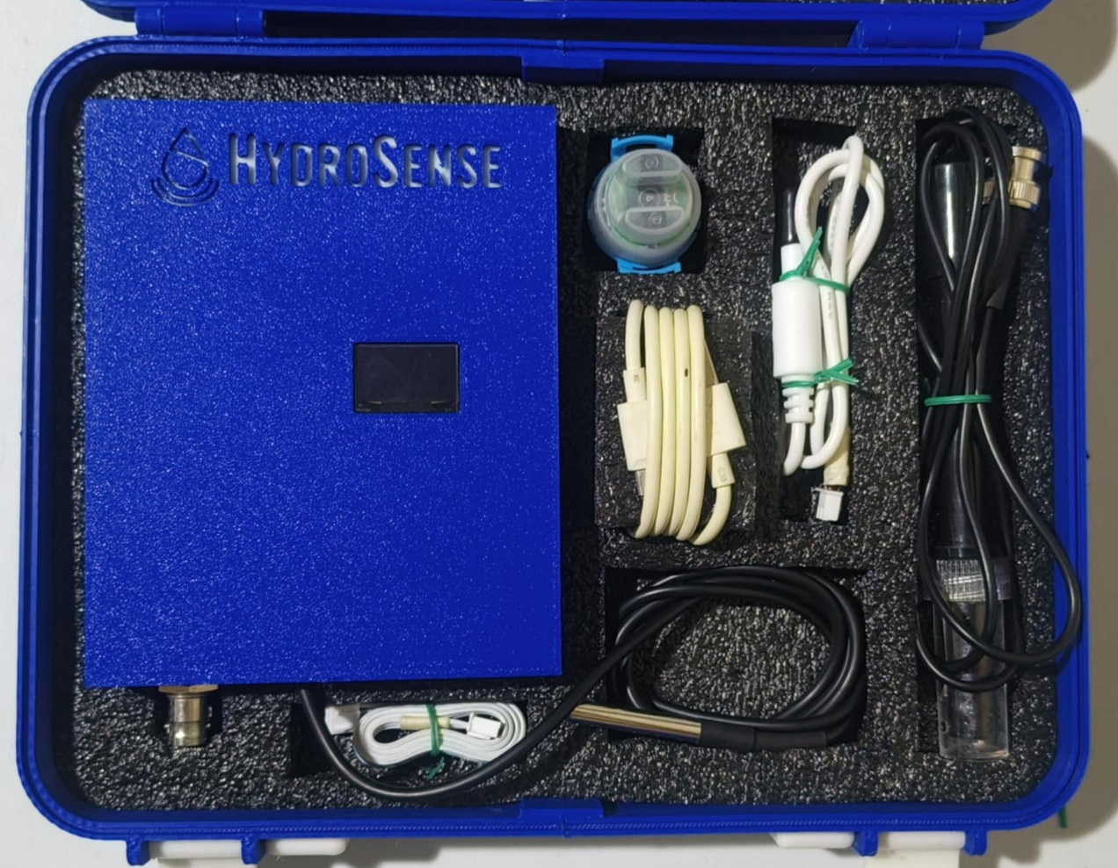

F.

D.

E.

E.

B.

C.

A.

Screenshot 1. Inside the Packaging.

A. HydroSense Device – It is the main device where every sensor be connected to.

B. Water Temperature Sensor – This sensor measures the water temperature.

C. pH Sensor – This sensor measures the pH of the water.

D. TDS Sensor – This sensor measures the total dissolved solids of the water.

E. Turbidity Sensor – This sensor measures how clear the water.

F. USB Type-C Cable – This cable is used to supply power to the HydroSense.

2. Connect the pH Sensor

To connect the pH sensor to HydroSense, align its BNC (Bayonet Neill–Concelman) connector with the corresponding port on the device. Ensure the connector is properly oriented to fit securely into the port located on the top of the HydroSense device. Screenshot 2 in the manual provides a visual reference for the appearance of the pH sensor BNC connector.

Screenshot 2. pH Sensor BNC Connector.

2.1 Identify the pH Sensor Port

The user must insert the pH sensor BNC connector into the HydroSense BNC port, ensuring a secure fit. The port is conveniently located at the top of the device making it easy to access. Refer to Screenshot 3 in the manual for a visual guide on where to insert the connector. This connection ensures the pH sensor is properly integrated with HydroSense for accurate readings.

A.

Screenshot 3. HydroSense BNC Port.

A. HydroSense BNC Connector – It is where the pH sensor BNC connector is to be attached to.

2.2 Insert the pH Sensor BNC Connector

The user must push the pH sensor BNC connector into the HydroSense BNC port and twist it securely until it locks in place. This ensures a firm and stable connection, preparing the sensor for accurate operation. Once connected, the pH sensor is ready to use. Screenshot 4 in the manual provides a visual example of the properly connected pH sensor.

Screenshot 4. Connected pH Sensor.

3. Connect the TDS Sensor

To connect the TDS sensor to HydroSense, align its 2-pin connector with the designated port on the device for a proper fit. Ensure the pins are correctly positioned to avoid any misalignment during connection. The manual includes Screenshot 5, which provides a visual reference for identifying the 2-pin connector. This step ensures the TDS sensor is ready for accurate water quality measurements.

Screenshot 5. TDS Sensor 2-pin Connector.

3.1 Identify the TDS Sensor Connector

The user must insert the TDS sensor 2-pin connector into the HydroSense 2-pin port, ensuring it fits securely. The port is conveniently located at the top of the device, just above the logo, for easy access. Refer to Screenshot 6 in the manual for a clear visual guide on where to insert the connector. Properly connecting the sensor ensures it is ready for accurate water quality monitoring.

A.

Screenshot 6. HydroSense 2-pin Port.

A. HydroSense 2-pin Connector – It is where the TDS sensor 2-pin connector is to be attached to.

3.2 Insert the TDS Sensor 2-pin Connector

The user must push the TDS sensor 2-pin connector firmly into the HydroSense port until it locks securely in place. This ensures a stable connection for accurate functionality. Once the connector is properly attached, the TDS sensor is ready for use. Screenshot 7 in the manual provides a visual example of the connected TDS sensor for reference.

Screenshot 7. Connected TDS Sensor.

4. Connect the Turbidity Sensor

To connect the turbidity sensor to HydroSense, align its 3-pin connector with the designated port on the device. Ensure the pins are properly oriented to fit securely into the port without forcing. Screenshot 8 in the manual provides a clear visual reference for identifying the 3-pin connector. This alignment step is crucial for accurate turbidity sensor functionality.

Screenshot 8. TDS Sensor 2-pin Connector.

4.1 Identify the Turbidity Sensor Connector

The user must insert the turbidity sensor 3-pin connector into the HydroSense 3-pin port, ensuring a secure and proper fit. The port is located at the top of the device, just above the logo, making it easy to locate. Screenshot 9 in the manual provides a visual guide to help identify the correct port for the connection. This step ensures the turbidity sensor is properly connected for reliable water quality readings.

A.

Screenshot 9. HydroSense 3-pin Port.

A. HydroSense 3-pin Connector – It is where the Turbidity sensor 3-pin connector is to be attached to.

4.2 Insert the Turbidity Sensor 3-pin Connector

The user must push the turbidity sensor 3-pin connector firmly into the HydroSense port until it locks securely in place. This ensures a stable and reliable connection for accurate sensor functionality. Once connected, the turbidity sensor is ready to measure water clarity. Screenshot 10 in the manual illustrates the correctly connected turbidity sensor for reference.

Screenshot 10. Connected Turbidity Sensor.

5. Power the Device

To power HydroSense, connect the USB Type-C cable to its corresponding port on the device. Ensure the cable is properly aligned for a secure fit. Screenshot 11 in the manual provides a visual reference for identifying the USB Type-C cable. This step prepares the device for operation by supplying it with the necessary power.

Screenshot 11. USB Type-C Cable.

5.1 Identify the USB Type-C Port

Insert the USB Type-C cable into the HydroSense USB Type-C port, ensuring a snug and secure connection. The port is conveniently located on the bottom side of the device for easy access. Screenshot 12 in the manual provides a clear visual guide to help identify the correct port for the cable. This step is essential for powering the device and enabling its functionality.

A.

Screenshot 12. HydroSense USB Type-C Port.

A. HydroSense USB Type-C Port – It is where the USB Type-C cable is to be attached to.

5.2 Insert the USB Type-C cable

Push the USB Type-C cable firmly into the HydroSense port until it locks securely in place, ensuring a stable connection. This step is crucial to providing a reliable power supply to the device. Once connected, HydroSense is ready to be powered and used. Screenshot 13 in the manual illustrates the properly connected USB Type-C cable for reference.

Screenshot 13. Connected USB Type-C Cable.

5.3 Power HydroSense using a Power Bank

Users power HydroSense using a power bank that supplies five volts and 2.1 amps for optimal performance. Simply connect the other end of the USB Type-C cable to the power bank output port. This portable power option allows HydroSense to function without being tethered to a fixed power source. Screenshot 14 in the manual shows an example of the device connected to a power bank for reference.

Screenshot 14. HydroSense Connected to a Power Bank.

5.4 Power HydroSense using a Phone Charger

Users power HydroSense using a phone charger that provides 5 volts and 2.1 amps, ensuring the device receives adequate power. Connect the other end of the USB Type-C cable to the charger output port. This method offers a convenient way to power HydroSense using a standard phone charging adapter. Screenshot 15 in the manual illustrates the connection between HydroSense and a phone charger.

Screenshot 15. HydroSense Connected to a Phone Charger.

5.5 HydroSense Power On State

When HydroSense is powered by either a power bank or a phone charger, the device activates, and the OLED screen lights up. Additionally, a red LED illuminates the HydroSense logo, indicating that the device is operational. This visual confirmation helps users know the device is receiving power and is ready for use. The illuminated OLED screen also displays system status information, ensuring users monitor functionality at a glance. This combination of visual cues enhances user confidence during operation. Screenshot 16 in the manual shows HydroSense in its powered-on state.

Screenshot 16. HydroSense Power On State.

6. Interface to HydroSense

With HydroSense turned on, the user connects to the device Wi-Fi access point named "ESP32_AP" to access the WiFiManager. After connecting, they open a web browser and navigate to “192.168.4.1” to access the WiFiManager interface. This interface provides options for configuring the device Wi-Fi settings and other functionalities. Screenshot 17 in the manual illustrates the WiFiManager interface users encounter. Once connected, the user ensures the device is properly linked to their local network for seamless operation.

E.

A.

B.

C.

D.

Screenshot 17. WiFiManager Interface.

A. Configure Wi-Fi Button – It opens a menu to see available Wi-Fi connections.

B. Info Button – It shows information regarding the internals of the device, used for debugging.

C. Exit Button – It exits the WiFIManager.

D. Update Button – A button that is used to update the firmware of HydroSense.

E. Wi-Fi Connection Feedback – It gives feedback if the previously connected Wi-Fi is not found.

6.1 Choose a Wi-Fi Connection

When the Configure Wi-Fi button is pressed in the WiFiManager, the user is directed to a screen displaying available Wi-Fi networks within range. This interface also shows the signal strength of each network, helping users choose the most reliable connection. Screenshot 18 in the manual provides a visual reference for this step, making it easy to navigate. Selecting a network and entering the credentials allows HydroSense to connect to the preferred Wi-Fi.

A.

B.

C.

D.

E.

F.

G.

H.

Screenshot 18. Choose a Wi-Fi Interface.

A. Available Wi-Fi Names – The user sees the available Wi-Fi and click it to copy the name to the SSID text field in C.

B. Wi-Fi Signal Indicator – Indicates the Wi-Fi signal strength.

C. SSID Text Field – The user types the name of the Wi-Fi they want to connect.

D. Password Text Field – The user puts the password of the Wi-Fi that corresponds to the SSID or Wi-Fi name.

E. Show Password Tick box – When ticked, the password typed is not obfuscated.

F. Save Button – When pressed, the Wi-Fi credentials are saved to HydroSense.

G. Refresh Button – Refreshed the Wi-Fi list in case new Wi-Fi connections is created.

H. Wi-Fi Connection Feedback – It gives feedback if the previously connected Wi-Fi is not found.

6.2 HydroSense Connecting to Wi-Fi Interface

When the save button is clicked, HydroSense begins attempting to connect to the Wi-Fi network using the credentials provided in the “Choose a Wi-Fi Connection” step. The device initiates the connection process and provides feedback on the progress through the application interface. Screenshot 19 in the manual illustrates this stage, giving users a clear idea of what to expect. A successful connection ensures HydroSense is ready for full functionality. If the connection fails, users are prompted to verify their credentials and try again. For further troubleshooting, consult the “Wi-Fi Connection Issues” section in the manual.

Screenshot 19. HydroSense Attempts to Connect to Wi-Fi.

6.3 Locate the Reboot Pinhole

After HydroSense attempts to connect to Wi-Fi, the device needs to be reset to finalize the setup process. The reset button is located on the left side of the USB Type-C port and is accessible through a small pinhole. Users use a pin or similar tool to press the button and reset the device. Screenshot 20 in the manual highlights the exact location of the reset pinhole for easy identification.

A.

Screenshot 20. Reboot Pinhole Location.

A. Reset Pinhole – A hole where the user put a pin to press the reboot button to reboot HydroSense.

6.4 HydroSense Ready State

Pressing the reset button prompts HydroSense to reconnect to the Wi-Fi network using the saved credentials. Once connected, the device displays the application IP address along with real-time sensor data on the screen. This information allows users to access the HydroSense interface and monitor water quality data. Screenshot 21 in the manual provides a visual example of the displayed information.

A.

Screenshot 21. Data Displayed in HydroSense Screen.

A. HydroSense Screen – Shows the IP address as well as sensor data.

6.5 Subject the Sensor to Water

The user prepares 2 containers containing the water the user wants to measure. The user then subjects the four sensors to the water. The water temperature sensor and the pH sensor go on the first container while the TDS and turbidity sensor go on the other container while minding that the turbidity sensor is not waterproof from the above and therefore must only be subjected halfway in the water. Screenshot 22 shows how the sensors are separated.

A.

C.

B.

D.

Screenshot 22. Subject the Sensor to Water.

A. Water Temperature Sensor – This sensor measures the water temperature.

B. pH Sensor – This sensor measures the pH of the water.

C. TDS Sensor – This sensor measures the total dissolved solids of the water.

D. Turbidity Sensor – This sensor measures how clear the water.

6.6 Access the HydroSense Application

To access HydroSense, the user must connect their device to the same Wi-Fi network as HydroSense. They then copy the IP address displayed on the HydroSense screen into their browser. This action opens the HydroSense homepage, which provides an interface for monitoring water quality and navigating its features. Screenshot 23 in the manual illustrates the appearance of the homepage once accessed.

Screenshot 23. Accessed HydroSense Homepage.

7. Homepage Interface

The HydroSense homepage interface displays real-time measurements of water quality parameters using four gauges: pH Level, TDS Level, Turbidity Level, and

Temperature. These gauges provide a clear and immediate overview of water conditions. Below the gauges, users find the Show More button for additional details and recommendations, and the Start Logging button to initiate data logging. Screenshot 24 in the manual visually represents the layout of the homepage.

Screenshot 24. HydroSense Homepage.

F.

E.

D.

C.

B.

A.

A. pH Level Gauge – This gauge indicates the acidity or alkalinity of the water.

B. TDS Level Gauge – This gauge reflects the concentration of dissolved particles in the water

C. Turbidity Level Gauge – This gauge indicates the water clarity or cloudiness.

D. Water Temperature Gauge – This gauge shows the water current temperature.

E. Show More Button – When clicked, reveals additional recommendations and health risk.

F. Start Logging Button – When clicked, allows the user to initialize data logging.

8. HydroSense Navigation Bar Interface

The Navigation Bar provides users with quick and convenient access to various sections of the HydroSense interface. It allows seamless traversal between the Home Page, Data Insights Page, Hydrology Resources Page, and About Page. Screenshot 25 in the manual illustrates the layout of the Navigation Bar for reference.

Screenshot 25. Navigation Bar Interface.

9. Recommendation and Health Risks Interface

Click the Show More button expands the interface to reveal detailed information about the water quality parameters. This includes recommendations for improving water safety and an assessment of associated health risks. The expanded view provides users with actionable insights and educational content based on the analyzed data. Screenshot 26 in the manual illustrates this detailed interface.

B.

C.

D.

E.

F.

A.

Screenshot 26. Health Risk Interface.

A. pH Level Summary – This part provides a brief summary of the pH Level.

B. TDS Level Summary – This part provides a brief summary of the TDS Level.

C. Turbidity Summary – This part provides a brief summary of the Turbidity.

D. Water Temperature Summary – This part provides a brief summary of the Water Temperature.

E. Recommendation Assessment – This part provides users with actionable guidance based on the analyzed water quality parameters.

F. Health Risk Assessment – This part educates users about the potential dangers of consuming water with the current quality parameters.

10. Live Data Interface

When the Start Logging button is activated, the user is redirected to the Live Data Interface, where real-time sensor data is displayed. The data is plotted on graphs, updating every second to provide a live view of water quality metrics. Screenshot 27 in the manual illustrates the layout and functionality of the Live Data Interface.

A.

B.

Screenshot 27. Live Data Interface.

A. Grouped Data Button – This button separates the four data streams into separate graphs.

B. Stop Logging Button – This button stops data logging and saves the data to memory.

11. Data Insights Interface

Press the Stop Logging button redirects the user to the Data Insights Interface, where all logged data is displayed. This interface allows users to review the recorded water quality measurements collected during the logging session. The organized presentation helps users analyze trends and patterns effectively. Screenshot 28 in the manual illustrates the appearance and functionality of the Data Insights Interface.

C.

B.

A.

Screenshot 28. Data Insights Interface.

A. Grouped Data Button – This button separates the four sensor data into separate graphs.

B. Hamburger Menu Button – This button drops a menu that gives different options for saving the data to the users’ own device.

C. Show More Button – This button reveals the previous saved data files as well as the showing each sensor data tick on a table of the currently opened save file.

12. Saved Data Interface

This interface displays the Saved Data and a corresponding Data Table for previously recorded water quality measurements. On the left, the Saved Data section lists filenames of CSV files containing logged data, allowing users to download these files for offline analysis. Each entry is accompanied by a Delete button, enabling users to remove unwanted records from the storage. On the right, the Data Table presents a detailed view of the logged water quality data including the timestamp. Screenshot 29 shows this.

C.

B.

A.

Screenshot 29. Saved Data Interface.

A. File Hyperlinks – When clicked directs the user to view that specific file to the Data Insights Interface.

B. Delete Button – This button deletes the file in line with the button.

C. Data Table – The table shows all the datapoints in the opened CSV file.

13. Hydrology Resources Interface

The Hydrology Resources Interface offers users educational and practical information on water quality and treatment. Topics are displayed in a list format, allowing users to click on each item to view detailed information in a popup window. This feature makes it easy to access relevant insights and guidance on maintaining and improving water quality. Screenshot 30 in the manual illustrates how the interface presents these resources.

B.

A.

C.

Screenshot 30. Hydrology Resources Interface.

A. Search Bar – The user search words and phrases related to a topic and related topics show at the bottom and non-related topics disappear.

B. Filter Buttons – The user filter specific topics by clicking the button related to the topic chosen.

C. Topic Buttons – The user click the button related to the topic chosen and a popup appear to educate them about the topic.

14. Specific Hydrology Resource Topic Interface

The interface includes an informative description, outlining key aspects related to the topic that is chosen. If a user clicks on “Water Safety,” Screenshot 31 shows key aspects like ensuring water quality for drinking, recreation, and environmental purposes, while emphasizing adherence to standards and practices that safeguard public health and environmental integrity. Additionally, it provides actionable insights and resources to help users maintain and improve water safety.

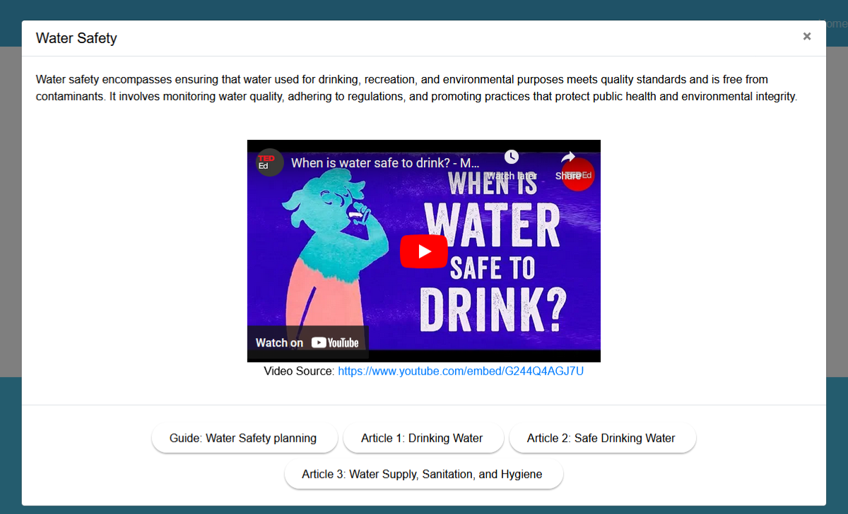

C.

B.

A.

Screenshot 31. Specific Hydrology Resource Topic Interface.

A. Play Button – The video plays if this button is pressed.

B. Video Source Hyperlink – The user click this button to open the source of the video.

C. Articles and Guides Buttons – When clicked, the user redirected to a site that has articles or guides about the topic chosen.

15. About Interface

The About Interface provides users with information about the HydroSense device, including details on its functionality and design. It also highlights insights about the developers and their role in creating the device. Screenshot 32 in the manual illustrates the layout of the About Interface.



Screenshot 32. About Interface.

Additionally, the page highlights the developers, "Stealthy Kitten," showcasing the developers with their respective roles. This section provides a comprehensive overview of HydroSense mission, technological framework, and the developers behind its creation. It reflects the team commitment to innovation and water quality management solutions. Users also gain insights into the inspiration and goals that guided the development of the device. Screenshot 33 shows this page and the developers.

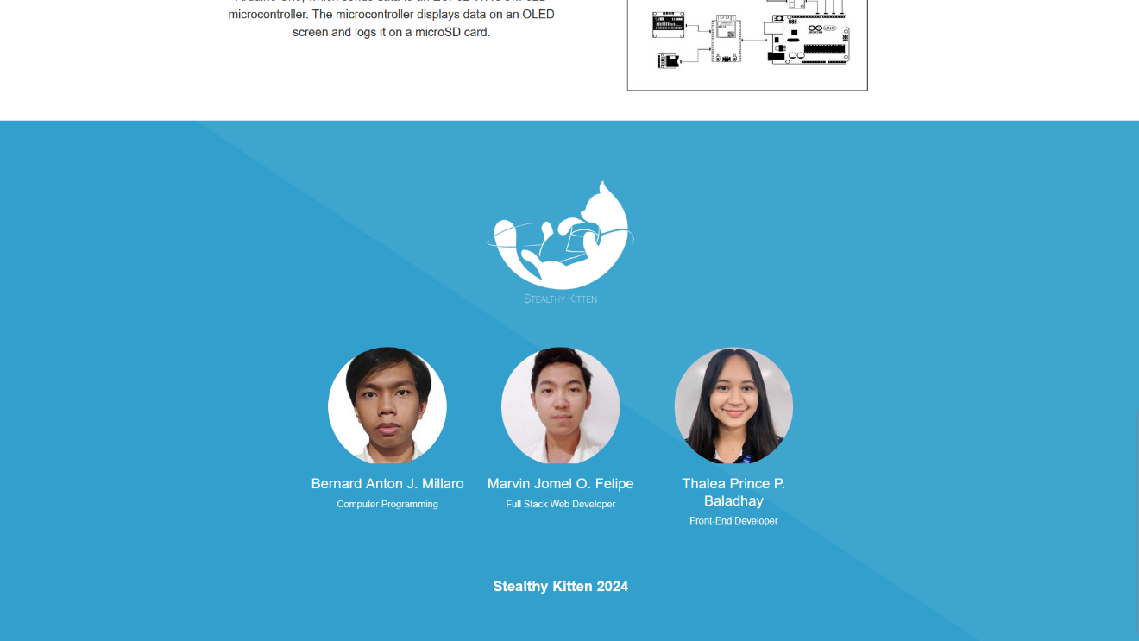

Screenshot 33. Stealthy Kitten.

The HydroSense user manual provides a comprehensive guide for setting up and using the device to monitor water quality. It explains how to connect the sensors, power the device, and access its web application. The interface includes features such as real-time data visualization, historical data logging, and educational resources on water quality. The manual also highlights additional functionalities, such as health risk assessments and developer information, for a complete user experience.